Vanuatu Investment Promotion Authority

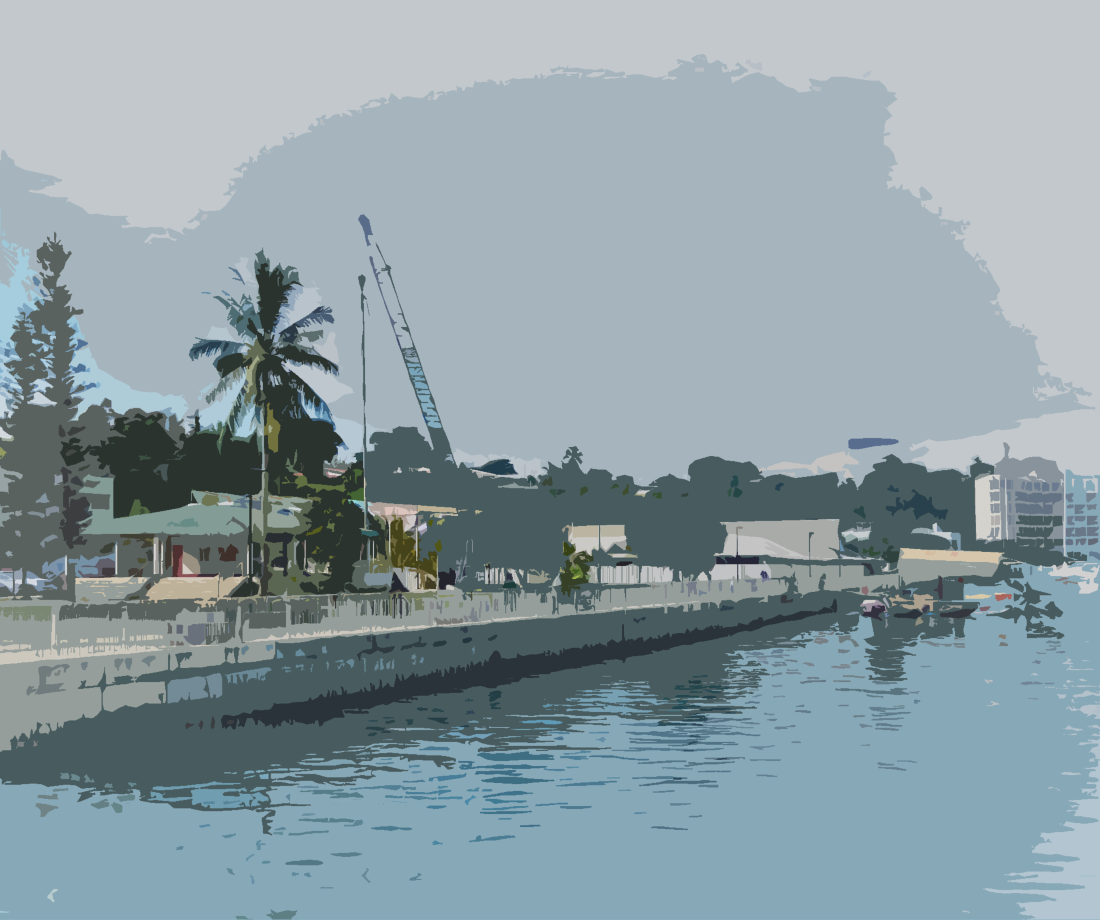
Business Plan Template

Contents
Business Plan 3
Investment details 3
Business/Company Name 3
Business Overview 3
Business Structure 3
Organizational Structure 3
Owner Experience & Expertise 3
Staff Capacity Building plan 3
Market Research 3
Product/Services 3
Target Market 3
Market Position 3
Product/Service Unique Selling Proposition (USP) 3
Pricing Method 3
Product/Service Growth Potential 3
Risk Management Strategy 3
SWOT Analysis 3
Financial Information 4
Funding Source 4
Expenditure Analysis 4
Profit and Loss Statement 4
Cash flow Projection 4

Business Plan

Investment details

Business/Company Name
(Please state the business/company name as registered with VFSC)

Business Overview
(Please clearly outline in brief what your business/company will be engaged in. Please state why you have chosen Vanuatu as your investment destination. Please indicate your business/company anticipated timeframe for full implementation)

Business Structure

Organizational Structure
(Clearly outline business/company organizational structure)

Owner Experience & Expertise
(Clearly detail relevant investor experience/expertise in investment proposal sector. Please provide evidence of qualifications.)

Staff Capacity Building plan
(Please clearly outline a training plan for employees including relevant training whether formal or informal)

Market Research

Product/Services
(Please indicate what products or services your business/company will be offering. Include the source of origin of any product/service whether you will source it locally or abroad)

Target Market
(Please state your product/service target market both domestically and internationally)

Market Position
(Please indicate your product/service market position domestically)

Product/Service Unique Selling Proposition (USP)
(Please indicate your product/service unique selling proposition. State clearly what sets your product/service apart from similar or like products already on the market)

Pricing Method
(Please indicate your pricing strategy taking into careful consideration domestic and international market factors)

Product/Service Growth Potential
(Please indicate your product/service potential growth)

Risk Management Strategy
(Clearly outline your risk management strategy)
Risk | Likelihood | Impact | Strategy

SWOT Analysis
(Provide a SWOT analysis of your product/service)

Financial Information

Funding Source
(Clearly state your funding availability including your funding source with its value)

Expenditure Analysis
(Please outline an expenditure analysis for your business/company)

Profit and Loss Statement
(Provide details of your profit and loss summary)

Cash flow Projection
(Please outline your cash flow projection)

